**Crime analysis Report**

### ****Introduction****

Crime analysis is important for law-and-order maintenance at any place. It helps the police department and law enforcement agencies to identify patterns of crime, which is crucial for the effective planning of a crime prevention program The purpose of this report is to analyze crime data, focusing on key metrics such as crime type distribution, geographical hotspots, time block of the majority of the events, trends over time, and the severity of incidents. This analysis aims to provide actionable insights to assist law enforcement agencies in making informed decisions to prevent and reduce crime.

### ****Dashboard Overview****

To meet the purpose, four type of dashboards are created in Tableau:

* 1. **Overall Crime Statistics Dashboard**:
* For personnel and resource management, the department needs to understand the count and types of crimes reported across the city. Mark the locations on a geo-map highlighting the locations with recent criminal history.
* Identify the most common criminal incidents reported
* In this introductory dashboard, include a live crime feed to exhibit the total number of crimes reported to date for the current year and the most recently reported crimes with their time and locations
  1. **Time Period Analysis Dashboard**:
* Along with locations, the study of crime statistics across time statistics is also crucial for understanding the patterns and planning those preventive strategies.
* Study distribution count of crime incidents across different time periods, such as day of the week or hour
* Further, explore the percentage of incident reporting for several time blocks (morning, afternoon, evening, and night)
  1. 3. **Trend Analysis Dashboard**:
  + Create a dashboard to study the change in crime rate over different years
  + Compare the change in the incident reporting over the years for the same date and time
  1. 4. **Comparative Analysis**:
* Study the distribution of incidents reported where an arrest was made vs. not.
* Identify what percentage of the reported incidents under each incident category are severe

Each dashboard provides unique insights into different aspects of crime data, including the distribution of crime by district, the geographical location of incidents, the severity of crimes, and incidents trends over different time of the year.

### ****Overall Crime Statistics Dashboard****

### Overall Crime Statistics Dashboard_ (1).png

#### ****District-wise Crime Count****

* **Visualization Description:** A bubble chart is used to visualize crime counts by district. Larger bubbles represent districts with higher crime counts.
* **Key Insights:** The district with the highest crime count is identified, with theft and battery being the most prevalent crimes. This suggests that certain districts may require more focused law enforcement efforts.

#### ****Locations on a Geo-Map****

* **Visualization Description:** A geo-map displays the distribution of crimes across different locations within the district.
* **Key Insights:** Crime hotspots are identified in specific areas, indicating regions where law enforcement should focus resources to mitigate crime.

#### ****Most Common Incidents****

* **Visualization Description:** A bar chart presents the frequency of various crime types, highlighting the most common incidents.
* **Key Insights:** Simple, Domestic battery simple, $500 and Under, Property theft, and retail theft are the most frequent crime types, indicating areas where preventive measures could be particularly effective.

#### ****Live Crime Feed****

* **Visualization Description:** A table provides a live feed of recent crime data, showing the location, type, and total number of incidents year wise.
* **Key Insights:** The data shows that in the year 2022, the majority of crimes occur on Sidewalks, in residential areas, street and in apartments, suggesting that these areas are vulnerable to criminal activity.

### ****Comparative Analysis Dashboard****

### Comparative Analysis.png

#### ****Severe Incidents Percentage****

* **Visualization Description:** A bar chart compares the percentage of severe vs. non-severe incidents across different crime types.
* **Key Insights:** Crimes such as criminal sexual assault, kidnapping and homicide are classified as severe, with criminal sexual assault having the highest percentage among severe crimes. This highlights the need for targeted interventions for these high-severity crimes.

#### ****Arrest Made or Not****

* **Visualization Description:** A pie chart shows the proportion of crimes that resulted in arrests.
* **Key Insights:** The data reveals that only 20.28% of incidents resulted in an arrest, indicating a significant gap in law enforcement's ability to apprehend offenders, especially in severe cases.

### ****Trend Analysis Dashboard****

### Designing the Trend Analysis Dashboard_ (1).png

#### ****Yearly Crime Rate Trend****

* **Visualization Description:** A line chart illustrates the crime rate trend on a yearly basis, showing how crime rates have changed over time.
* **Key Insights:** The trend indicates a sharp decline in crime rates from 2017 to 2022. The most significant drop occurred between 2018 and 2020, suggesting the impact of new policies or interventions during that period.

#### ****Crime Rate Trend Date Wise****

* **Visualization Description:** Another line chart provides a more detailed view of crime trends on a date-wise basis.
* **Key Insights:** The date-wise analysis shows a marked decrease in crime rates over time, with occasional spikes that could correspond to specific events or seasonal factors.

### Time Period Analysis Dashboard

### Time Period Analysis Dashboard.png

### ****Distribution of Crime by Time****

### ****Visualization:** The bar chart is plotted to analyze the distribution of the crime occurred during different times of the day. Also one more bar chart was made to see the reported maximum incidents based on different time blocks like Morning, Afternoon, Evening or Night to make a proper monitory system.**

### ****Key Insights:** It is been observed from the two bar graphs that most of the incidents take place at either in the Afternoon times or in the night time of the day i.e., around 12 PM and between 17 PM to 24 AM.**

### ****Summary of Findings****

* **Overall Crime Patterns:** Theft and battery are the most common crimes, with specific districts and locations identified as hotspots.
* **Severity of Incidents:** Severe crimes such as criminal sexual assault require urgent attention, as they constitute a significant portion of severe incidents, yet arrest rates remain low.
* **Trends Over Time:** The overall crime rate has been declining sharply since 2017, with occasional fluctuations that may warrant further investigation.
* **Most Incidents Reported Time block:** The majority of the crimes take place during the afternoon and the evening time blocks.

### ****Actionable Recommendations****

* **Targeted Policing:** Focus law enforcement efforts on districts and areas identified as crime hotspots, with particular attention to simple, theft and battery incidents.
* **Address Severe Crimes:** Implement specialized task forces or strategies to combat severe crimes like criminal sexual assault, kidnapping and homicide, ensuring that these cases lead to higher arrest rates.
* **Monitor Trends:** Continue monitoring crime trends over time, particularly around dates and the time blocks where spikes occur, to better understand and address the underlying causes.

### ****Conclusion****

This report highlights critical areas of concern in crime patterns and provides recommendations for law enforcement strategies. By focusing on identified hotspots, improving arrest rates for severe crimes, more focus on crimes at afternoon and night times, and closely monitoring trends, law enforcement agencies can more effectively reduce and prevent crime.

### ****Appendices****

* **Dashboard Screenshots**

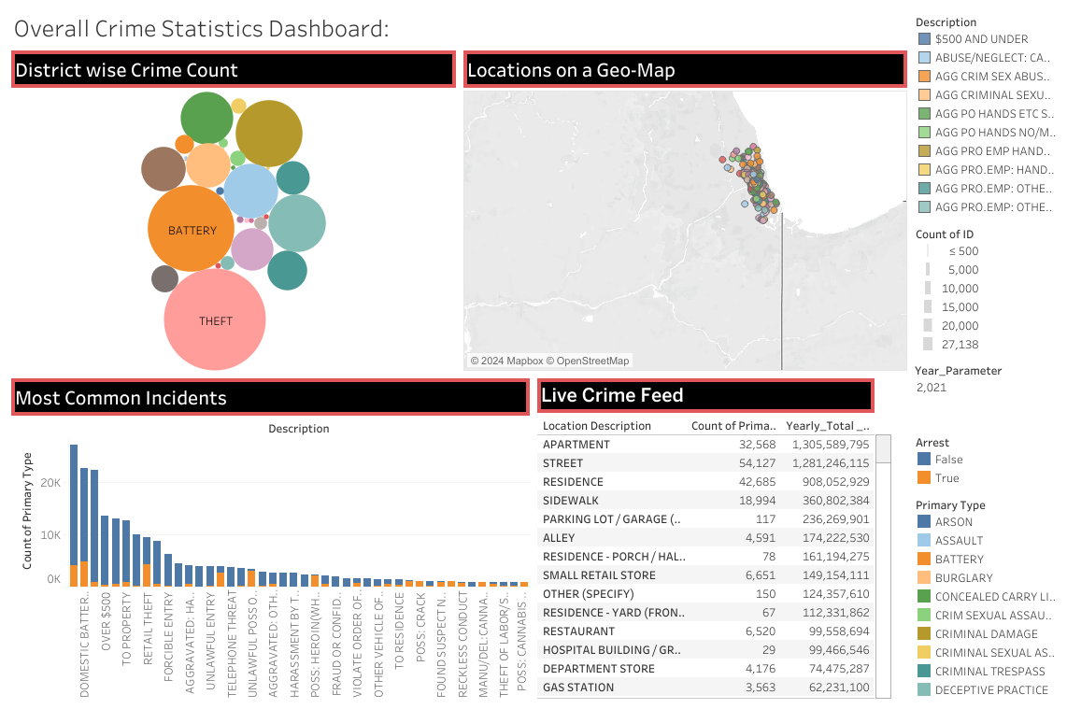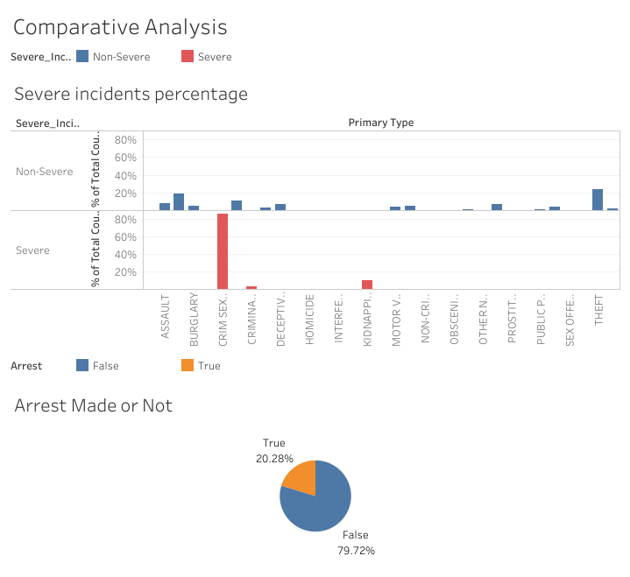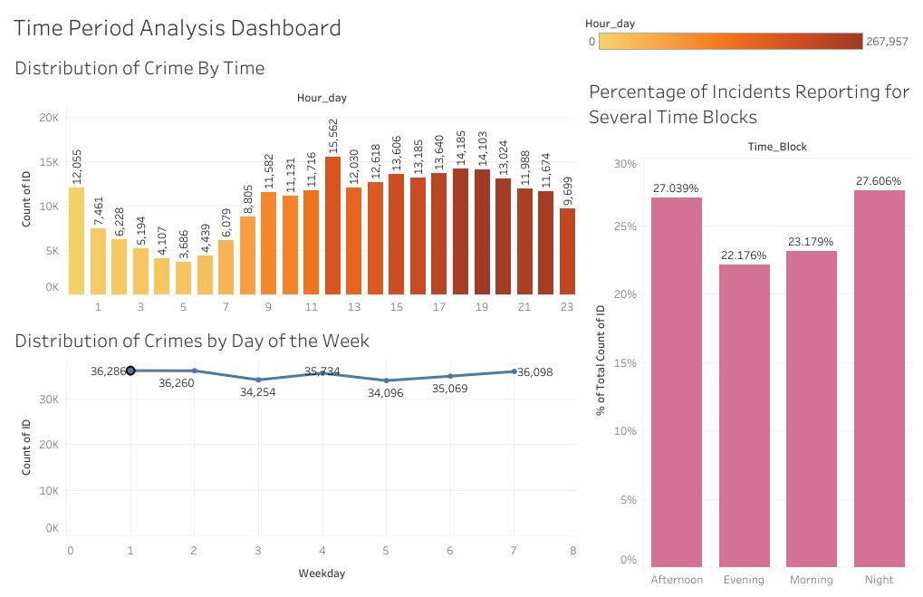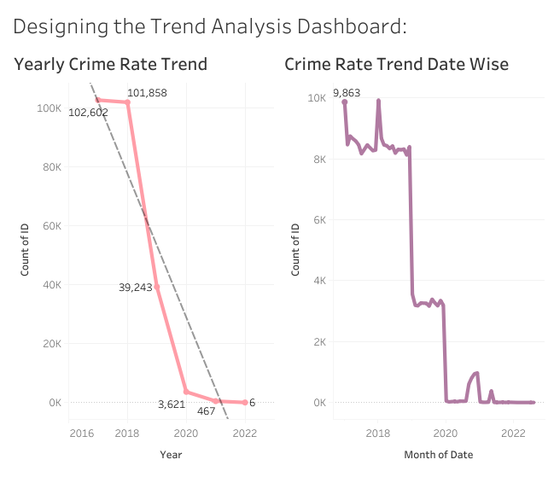

**Link for the Tableau dashboard**

[**https://public.tableau.com/app/profile/rupali.rupali/viz/Crime\_Analysis\_17235759473930/TimePeriodAnalysisDashboard?publish=yes**](https://public.tableau.com/app/profile/rupali.rupali/viz/Crime_Analysis_17235759473930/TimePeriodAnalysisDashboard?publish=yes)